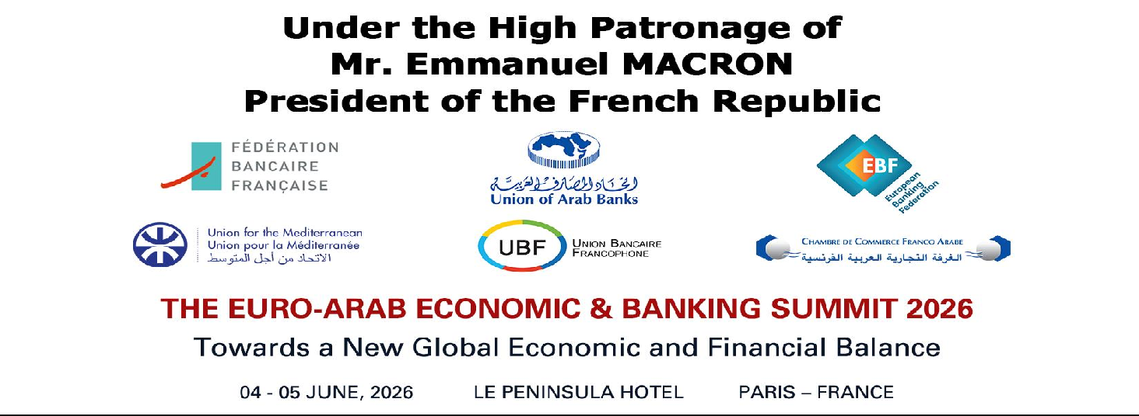

Attendance List – UAB VIP Guests
(as 3 June 2026)

- Chairman, Union of Arab Banks (UAB)
Mr. Mohamed M. El-Etreby
- Chairman, World Union of Arab Bankers (WUAB)
Chairman, Executive Committee of Union of Arab Banks (UAB)
Dr. Joseph Torbey
- Special Envoy of President MACRON for the India, Europe Economic Corridor (IMEC)
Mr. Gérard MESTRALLET
- Conseillère Afrique du Nord et Moyen-Orient du président de la République Française, Pôle Diplomatique de l’Elysée
Mrs. Dora CATTUTI
- Executive Director, International Monetary Fund (IMF) / Washington, D.C. Head of Arab Group and Maldives
His Excellency Dr. Mohamed Maait
- Minister of Finance in Qatar
H.E. Mr. Ali bin Ahmed Al Kuwari
- Minister of Finance in Lebanon
H.E. Mr. Yassine Jaber
- Minister of Finance in Syria
H.E. Dr. Yisr Bernieh

- Minister of Information in Lebanon
H.E. Dr. Paul Morkos

- Chairman, AAOIFI / Bahrain
H.E. Sheikh Ebrahim bin Khalifa Al Khalifa

- Governor, Central Bank of Libya
H.E. Mr. Naji Mohammed Issa Belgasem
- Governor, Central Bank of Mauritania
H.E. Mr. Mohamed-Lemine DHEHBY
- Governor, Central Bank of Sudan
H.E. Ms. Amina Mirghani Hassan Al-Tom
- Chairman, Kuwait International Bank / Kuwait
H.E. Sheikh Mohamed Jarrah Al Sabah

- Group CEO, Qatar National Bank / Qatar
H.E. Mr. Abdullah Mubarak Al Khalifa

- Group Chief Business Officer, Qatar National Bank/ Qatar Mr. Youssef Mahmoud Al-Naimi

- Group CEO, Doha Bank / Qatar
H.E. Sheikh Abdulrahman Bin Fahad Bin Faisal Al Thani

- CEO, Qatar International Islamic Bank / Qatar
Dr. Abdulbasit Ahmed AlShaibei

1- Advisor to the CEO, The Qatar Investment Authority / Qatar
Board Member, Al Khaliji France
His Excellency Sheikh Ali bin Jassim bin Mohamed Jassam Al Thani

- Head of Health, Safety, Environment & Facilities Management, Ahli Bank / Qatar
Mr. Adel Hussain Abdulla
- Chairman, Association of Banks in Lebanon
Dr. Salim Sfeir

- Chairman, Iraqi Private Banks League (IPBL)
Mr. Wadeeh Al-Handhal

- Ambassador of the Arab League to the French Republic
H.E. Mr. Naji Abi ASSI

- Ambassador of the State of Qatar to the French Republic
H.E. Sheikh Ali bin Jassim Al-Thani

- Ambassador of the Republic of Lebanon to the French Republic
His Excellency Mr. Rabih Chaer
- Ambassador of the Republic of Iraq to the French Republic
H.E. Mr. Thair AL-JUMALI
AND Mrs. Rusul ALSHAKIR, chargé des affaires économiques à l’Ambassade, AND M. Ali AL-RUBAYE, Attaché commercial adjoint
- Ambassador of the Sultanate of Oman to the French Republic
H.E. Mr. Ahmed Bin Mohamed Bin Nasser AL-ARAIMI
- Ambassador of the Kingdom of Morocco to the French Republic
H.E. Mrs. Samira SITAIL
AND Mrs. Asmae EL-MEKHFI – Conseiller to the Ambassador
- Ambassador of the Republic of Yemen to the French Republic
H.E. Dr. Reyad Yassin ABDULLAH
- Ambassador of the Hashemite Kingdom of Jordan to the French Republic
H.E. Ms. Leena AL-HADID
AND Mme. Balqees Al Bahri - Attachée Diplomatique
- Chargé d'Affaires, Embassy of the Arab Republic of Syria to the French Republic
Mr. Louay FALLOUH
- Chargé d'Affaires, Embassy of Republic of Libya to the French Republic
Mr. Mohamed HAMUDA
- Embassy of the Kingdom of Bahrain to the French Republic
Mr. Rashed Bindaina, Deuxième Secrétaire de l'Ambassade

- Secretary General, Union for the Mediterranean (UfM), Spain
H.E. Mr. Nasser KAMEL

- President, International Chamber of Commerce (ICC), France
Mr. Matthias Fekl
- President, Franco-Arab Chamber of Commerce (CCFA), France
H.E. Mr. Raoul DELAMARE
- Director General, French Banking Federation (FBF), France
Mrs. Maya ATIG

- Deputy CEO, European Banking Federation (EBF), Brussels
Mr. Sebastien De Brouwer
- President, Arab Open University / Kuwait
H.E. Prof. Dr. Mohamed Zakari

- President, Lebanese Economic Organizations / Lebanon
H.E. Mr. Mohamed CHOUKEIR

- President, the Joint Italian Arab Chamber of Commerce / Italy Mr. Pietro Paolo Rampino

- President, Conseil Bancaire et Financier (CBF) / Tunisia Mr. Néji GHANDRI

- Secretary General, Union of Arab Chambers (UAC)
H.E. Dr. Khaled Hanafi

- Chairman – General Manager, Banque De L’habitat / Lebanon Mr. Antoine A. Habib
- Chairman, Banking Control Commission of Lebanon
Dr. Mazen Soueid
- Secretary General, Banking Control Commission of Lebanon
Mr. Hasan Khalifa
- Secretary General, Association of Banks in Lebanon
Dr. Fadi Khalaf
- Executive Board Member, Banking Control Commission of Lebanon
Mr. Nader Haddad

- Director General, Arab Information & Communication Technology Organization (AICTO) /Tunis
H.E. Eng. Mohamed Ben Amor

- Secretary General, the Council of Arab Economic Unity / Egypt
H.E. Ambassador Mohamedi Ahmed AL-NAY
- President, The Arab Academy for Management, Banking and Financial Sciences (AAMBFS) Dr. Mustafa Hodeib
- Deputy Director General Financial Stability & Opertions, Banque de France / France
Mr. Philippe MONGARS
- Director of Development & External Relations Dept., Chambre De Commerce Franco Arabe
Mr. Dominique BRUNIN
- Director, Total Energies / France
Mrs. Isabelle PATRIER

- General Manager, Banca UBAE / Italy
Mr. Maurizio Valfrè

- Director of the Middle East and North Africa, U.B.A.F/ France Mr. Youssef Ben HENDA

- President, Libyan Banks Association / Libya Mr. Abdulrazzag AL-HOUSH

- Director General, GPBM/ Morocco Dr. El-Hadi CHAIBAINOU

- Board Member of the World Union of Arab Bankers / UAE Mr. Adnan Al-ISMAIL
- Head of Retail and Corporate Banking, Ruya Bank / UAE Mr. Abdulaziz ALMANDOUS
- Chairman, Yemen Banks Association in Aden / Yemen Dr. Ahmed BEN SUNKR

- Chairman, National Bank of Yemen / Yemen Mr. Mohamed Hussein HALBOOB

- Chairman, SPM-Economic Project Management Consultancy / Lebanon Mr. Nabil SOUBRA

- Member of the Board of Directors & Head of Banking Commission, International Chamber of Commerce (ICC) / Saudi Arabia
Mr. Osama Ahmed Ben Saleh BUKHARI

- CEO, Banque Intercontinentale Arabe (BIA) / France Mr. Mustafa BEN KHALIFA

- Chief Executive Officer, Arab Banking Corporation/ France Mr. Frédéric LE SERRE

- General Manager, IBH/Levant & Africa / Lebanon Mr. Elie GEAHCHAN

- President, National Financial Intelligence Authority / Morocco Mr. Jawhar NFISSI

- CEO, Monty Group / Lebanon Mr. Montaser Hashem

